## ECS 171 Homework Set 1 Haozhe Gu 999200555

1. The threshold for three categories are:





1. From the plots below, we can see the plot of Weight Vs Model year (6,4) or (4,6) might have the best separation regard to three categories.

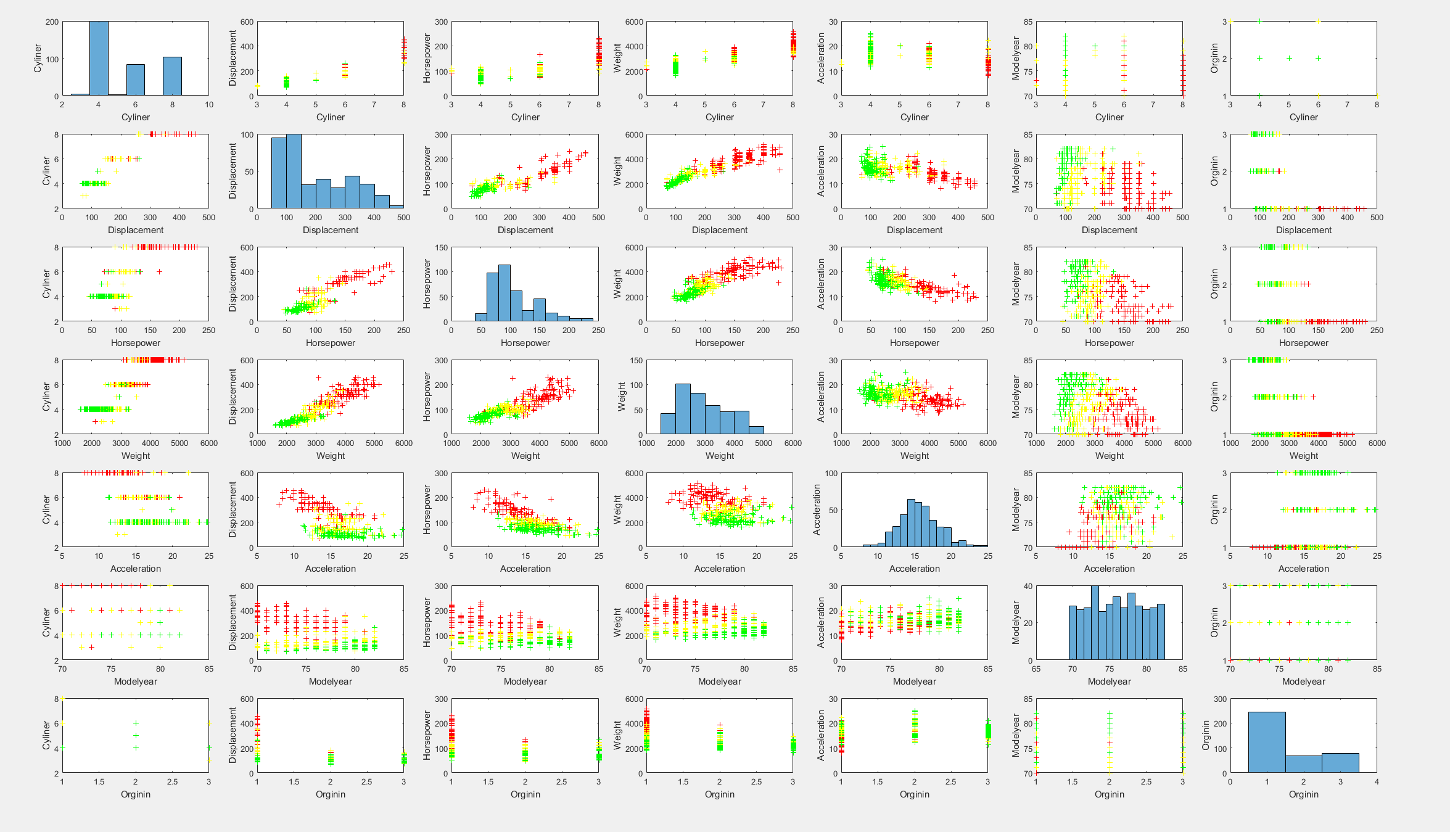

1. The file ECS171Q3.m is my solver that integrated OLS and Logistic Linear Regression.

The part below respond to OLS.



1. The following seven graphs are for predict lines and testing data.

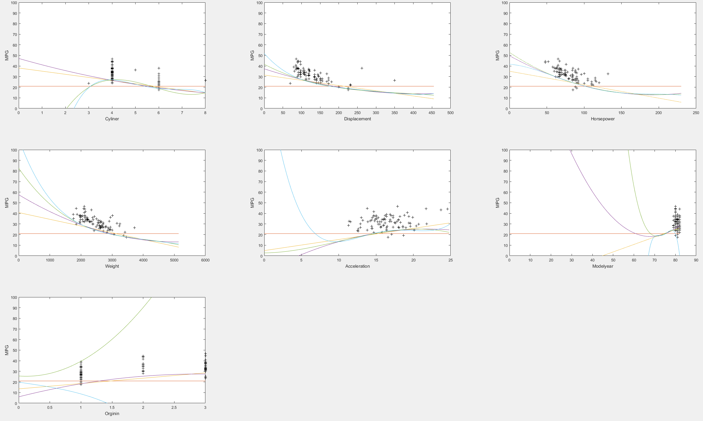

Training MSE (rows correspond to 0th order, 1st order… 4th order; columns correspond to 7 individual features: "Cyliner" "Displacement" "Horsepower" "Weight" "Acceleration" "Modelyear" "Orginin")

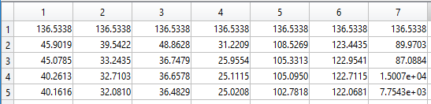

Testing MSE (Same format as training MSE)

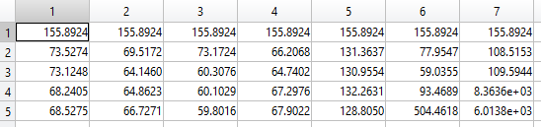

Best order:

|  |  |  |  |  |  |  |
| --- | --- | --- | --- | --- | --- | --- |
| **Cylinder** | **Displacement** | **Horsepower** | **Weight** | **Acceleration** | **Modelyear** | **Orginin** |
| **3rd** | **2nd** | **4th** | **2nd** | **4th** | **2nd** | **1st** |

The most informative feature should be horsepower because it gives the best prediction.

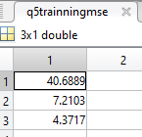 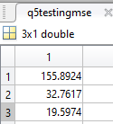

1. Solver is in file ECS171Q3.m

.





Also, detail information can be found in part1(training) & parttest(testing) matrix

Part1 consist of

1. MPG
2. Value of first logistic regression for separating low and (median+high)
3. Result category of logistic regression (0 means low, 1.5 means above below)
4. Value of second logistic regression for separating median and high
5. Result category of logistic regression (1 means medium, 2 means high)
6. Logical True (1) or False (0) for correctness of categorization

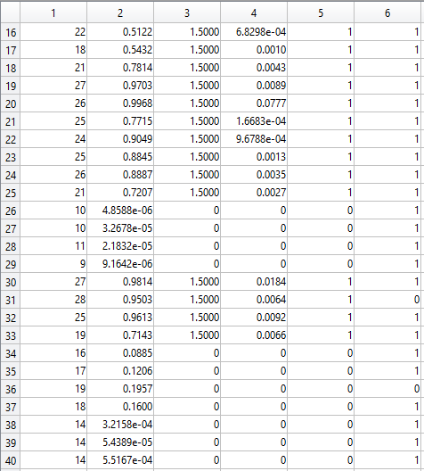

1. Prediction using 2nd order, multivariate linear regression



Prediction using 2nd order, multivariate Logistic regression (actually only need first classification, because result is low, don’t need to categorize between medium and high. Value of sigmoid is less than 0.5, thus categorize into low)



1. For a horse, the intuitive answer to its miles per gallon should be 0 because horse don’t consume gasoline. But if we are considering from an energy standpoint, then the energy required by the horse can be transformed in to miles per gallon.

From the online source:

* A standard gallon of gas has 35,249 Joules
* 1000 lb. performance moderate work horse consume 21,200 cal/day

Thus, a horse uses 2.52 gallons gas equivalent energy per day. Assume the horse dragging the car 25 miles per day, then the MPG of this horse should be approximately 9.93.